# “FACULTY DOT CUTMAP”

### A Project report submitted

**In the partial fulfillment the award of degree of**

**BACHELOR OF TECHNOLOGY**

**IN**

**COMPUTER SCIENCE AND ENGINEERING (2022-2023)**

**BY**

**B MAHI SAI SUJAN Reg.No.211801390008**

**V.SIVA HARSHA Reg.No.211801360012**

**SUJITH SUDHAKHARAN Reg.No.211801360013**

**CH.RAKESH Reg.No.211801360014**

**R.KARTHIK JAIRAJ Reg.No.211801360020**

**Under the esteemed Guidance of**

**Mrs. G. Rama Devi, M.Tech,(Ph.d),Asst. Professor**

**CENTURION UNIVERSITY SCHOOL OF ENGINEERING AND TECHNOLOGY**

**Rollavaka village, Tekkali mandal 535003**

**(2022-2023)**

##### CENTURION UNIVERSITY OF TECHNOLOGY AND MANAGEMENT

**ANDHRA PRADESH**

**(2019-2023)**

##### DEPARTMENT OF COMPUTER SCIENCE AND ENGINEERING

BONAFIDE CERTIFICATE

##### This is to certify that the project work entitled “FACULTY DOT CUTMAP” is a fulfillment of project work done by **B MAHI SAI SUJAN** (Reg.No.211801390008), V.SIVA HARSHA(Reg.No.21180160012),SUJITHSUDHAKHARAN(Reg.No.211801360013),CH.RAKESH(Reg.No.211801360014),R.KARTHIK JAIRAJ(Reg.No,211801360020) for the award the degree of BACHELOR OF TECHNOLOGY in COMPUTER SCIENCE AND ENGINEERING,CENTURION UNIVERSITY OF TECHNOLOGY AND MANAGEMENT, during the academic year 2022-2023.

##### INTERNALGUIDE HEAD OF THE DEPARTMENT

##### Mrs .G. Rama Devi Mr.R. Lakshmana Rao

**Asst. Professor Asst. Professor**

**Dept. of CSE Dept. of CSE**

**EXTERNAL EXAMINER**

**ACKNOWLEDGEMENT**

It is with at most pleasure and excitement we submit our project partial fulfillment of the requirement for the award of Bachelor of Technology.

The project is a result to the cumulative efforts, support, guidance, encouragement and inspiration from many of those for whom we have to give our truthful honor and express gratitude through bringing out this project at the outset as per our knowledge.

I convey my special thanks to our project **Guide Mrs. G. Rama Devi(Asst. Professor)** who has guided, encouraged and tremendously supported me to enhance my knowledge with present working of this project to bring out enriching the quality of project.

I express my appreciate to **Mr. R.LAKSHMAN RAO(Asst. Professor) and Head of the Department,** who facilitated us to providing the friendly environment which helped to enhance my skills in present project.

I would also like to extend my gratitude to **Dr. K. V. G. KRISHNA MURTHY, Dean-School of Engineering And Technology, Centurion University of Technology and Management** who has helped us to attain all the requirements of the project.

I convey my sincere thanks to **Dr. RAMANA RAO, Ph. D Registrar of Centurion University of Technology and Management** who provided us with an opportunity to take on project work in well-equipped laboratories of Computer Science Department in our college.

At the outset, we thank to **Sri. G.S.N.RAJU**, beloved **Vice Chancellor of Centurion University of Technology and Management** who is the back bone by providing for completion of this project, Thank you sir.

**DECLA****RATION**

I hereby declare that the project entitled **“FACULTY DOT CUTMAP”** submitted to the fulfillment of award the degree of **B.TECH (CSE)** in **CENTURION UNIVERSITY OF TECHNOLOGY AND MANAGEMENT**, **ANDHRA PRADESH.**

|  |  |
| --- | --- |
| B MAHI SAI SUJAN | 211801390008 |
| V SIVA HARSHA | 211801360012 |
| SUJITH SUDHAKHARAN | 211801360013 |
| CH RAKESH | 211801360014 |
| R KARTHIK JAIRAJ | 211801360020 |

FACULTY DOT CUTMAP

# 

# Table of Contents

Table of Figure(s) 4

1. Introduction 5

1.1 Purpose 5

1.2 Scope 5

1.3 Definitions, Acronyms and Abbreviations 5

1.4 References 6

1.5 Overview 6

2. Overall Description 6

2.1 Product Perspective 6

2.1.1 System Interface 6

2.1.2 User interface 6

2.1.3 Hardware Interface 6

2.1.4 Software Interface 7

2.1.5 Communication Interfaces 7

2.1.6 Memory Constraints 7

2.1.7 Operations 7

2.1.8 Implementation 7

2.2 Product functions 8

2.2.1 Context Diagram 8

2.2.2 Use Case Diagrams 8

2.2.3 Use case descriptions /Introductions 13

2.3 User Characteristics 16

2.3.1 Students 16

2.3.2 Professors 16

2.3.3 System Administrators 16

2.4 Constraints 16

2.4.1 User Interface Constraints 16

2.4.2 Hardware Constraints 17

2.4.3 Software Constraints 17

2.4.4 Data Management Constraints 17

2.4.5 Operational Constraints 17

2.4.6 Site Adaptation Constraints 17

2.4.7 Design Standards Compliance 17

2.5 Assumptions and dependencies 17

2.6 Apportioning of Requirements 17

Integration of LDAP login might be apportioned to future versions 17

3. Specific Requirements 18

3.1 External interface 18

3.1.1 Web Server 18

3.1.2 PHP Application 18

3.1.3 MySQL Database 18

3.2 Functional Requirements 18

3.2.1 Use Case Scenario 18

3.3 Performance Requirements 25

3.4 Logical database requirements 25

3.5 Design Constraints 25

3.6 Software System Attributes 25

**1.Introduction**

The "College Website" has been developed to override the problems prevailing in the practicing manual system. This software is supported to eliminate and in some cases reduce the hardships faced by this existing system. Moreover this system is designed for the particular need of the company to carry out operations in a smooth and effective manner.

The application is reduced as much as possible to avoid errors while entering the data. It also provides error message while entering invalid data. No formal knowledge is needed for the user to use this system. Thus by this all it proves it is user-friendly. College Website , as described above, can lead to error free, secure, reliable and fast management system. It can assist the user to concentrate on their other activities rather to concentrate on the record keeping. Thus it will help organization in better utilization of resources.

Every organization, whether big or small, has challenges to overcome and managing the information of Student, College, Course, Faculty, Fees. Every College Website has different College needs, therefore we design exclusive employee management systems that are adapted to your managerial requirements. This is designed to assist in strategic planning, and will help you ensure that your organization is equipped with the right level of information and details for your future goals. Also, for those busy executive who are always on the go, our systems come with remote access features, which will allow you to manage your workforce anytime, at all times. These systems will ultimately allow you to better manage resources.

The purpose of College Website is to automate the existing manual system by the help of computerized equipment's and full-fledged computer software, fulfilling their requirements, so that their valuable data/information can be stored for a longer period with easy accessing and manipulation of the same. The required software and hardware are easily available and easy to work with.

College Website, as described above, can lead to error free, secure, reliable and fast management system. It can assist the user to concentrate on their other activities rather to concentrate on the record keeping. Thus it will help organization in better utilization of resources.

## 1.1 Objective of this Project on College Website:

The main objective of the Project on College Website is to manage the details of College, Student, Employee, Course, Fees. It manages all the information about College, Faculty, Fees, College. The project is totally built at administrative end and thus only the administrator is guaranteed the access. The purpose of the project is to build an application program to reduce the manual work for managing the College, Student, Faculty, Employee. It tracks all the details about the Employee, Course, Fees.

## Functionalities provided by College Website are as follows:

* Provides the searching facilities based on various factors. Such as College, Employee, Course, Fees
* College Website also manage the Faculty details online for Course details, Fees details, College.
* It tracks all the information of Student, Faculty, Course etc
* Manage the information of Student
* Shows the information and description of the College, Employee
* To increase efficiency of managing the College, Student
* It deals with monitoring the information and transactions of Course.
* Manage the information of College
* Editing, adding and updating of Records is improved which results in proper resource management of College data.
* Manage the information of Course.

**1.2 Scope of the project:**

It may help collecting perfect management in details. In a very short time, the collection will be obvious, simple and sensible. It will help a person to know the management of passed year perfectly and vividly. It also helps in current all works relative to College Website. It will be also reduced the cost of collecting the management & collection procedure will go on smoothly.

Our project aims at Business process automation, i.e. we have tried to computerize various processes of College Website.

* In computer system the person has to fill the various forms & number of copies of the forms can be easily generated at a time.
* In computer system, it is not necessary to create the manifest but we can directly print it, which saves our time.
* To assist the staff in capturing the effort spent on their respective working areas.
* To utilize resources in an efficient manner by increasing their productivity through automation.
* The system generates types of information that can be used for various purposes.
* It satisfy the user requirement
* Be easy to understand by the user and operator
* Be easy to operate
* Have a good user interface
* Be expandable

**1.3 References**

* Google for problem solving
* http://www.javaworld.com/javaworld/jw-01-1998/jw-01-Credentialreview.html
* Database Programming with JDBC and Java by O'Reilly
* Head First Java 2nd Edition
* http://www.jdbc-tutorial.com/
* Java and Software Design Concepts by Apress
* https://www.tutorialspoint.com/java/
* http://www.javatpoint.com/java-tutorial
* https://docs.oracle.com/javase/tutorial/
* http://www.wampserver.com/en/
* http://www.JSP.net/
* http://www.tutorialspoint.com/mysql/
* httpd.apache.org/docs/2.0/misc/tutorials.html

**1.4 Overview**

A college website system is a digital platform designed to know the college details, faculty details, and courses offered in college through an online website. It provides students with a convenient and efficient way to know about college and get knowledge about what to opt and understanding of infrastructure, while also offering students a flexible and interactive meet sessions in online through college website.

1. **Overall Description**
   1. **Product perspective**

The product perspective for a college website involves understanding the website as a tool to meet the needs of its users, including prospective and current students, faculty, staff, alumni, and other stakeholders.

**2.2 System Interface**

Xampp will be used as web server. The user inputs data via the web server using PHP forms. The actual program that will perform the operations is written in HTML, CSS, JAVA Script.

**2.3 User Interface**

This system used by the user to login into system. A user must login with his user name and password to the system after registration. If they are invalid, the user not allowed to enter the system. A new user will have to register in the system by providing essential details in order to view the products in the system. The admin must accept a new user by unblocking him.

**2.4 Hardware Interface**

a) Server side:

Xampp will be used as web server. The user inputs data via the web server using PHP forms.

b) Client side:

Monitor screen – the software shall display information to the user via the monitor screen

Mouse – the software shall interact with the movement of the mouse and the mouse buttons. The mouse shall activate areas for data input, command buttons and select options from menus.

Keyboard – the software shall interact with the keystrokes of the keyboard. The keyboard will input data into the active area of the database.

**2.5 Software Interface**

a) Server side

An Apache web server will accept all requests from the client and forward it accordingly. A database will be hosted centrally using MySQL.

b) Client side

An OS which is capable of running a modern web browser which supports JavaScript and HTML5.

**2.6 Communication Interfaces**

The HTPP or HTTPS protocol(s) will be used to facilitate communication between the client and server.

**2.7 Memory Constraints**

Memory constraints will come into play when the size of MySQL grows to a considerable size.

**2.8 Operations**

The product shall have operations to protect the database from being corrupted or accidentally altered during a system failure.

**3. Context Diagram**

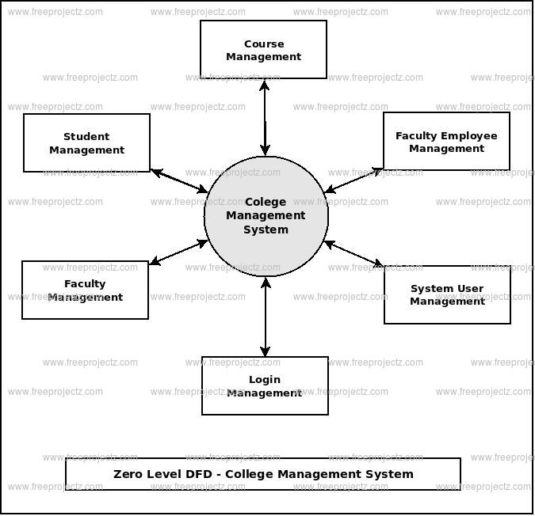

**4. Layer Architecture**

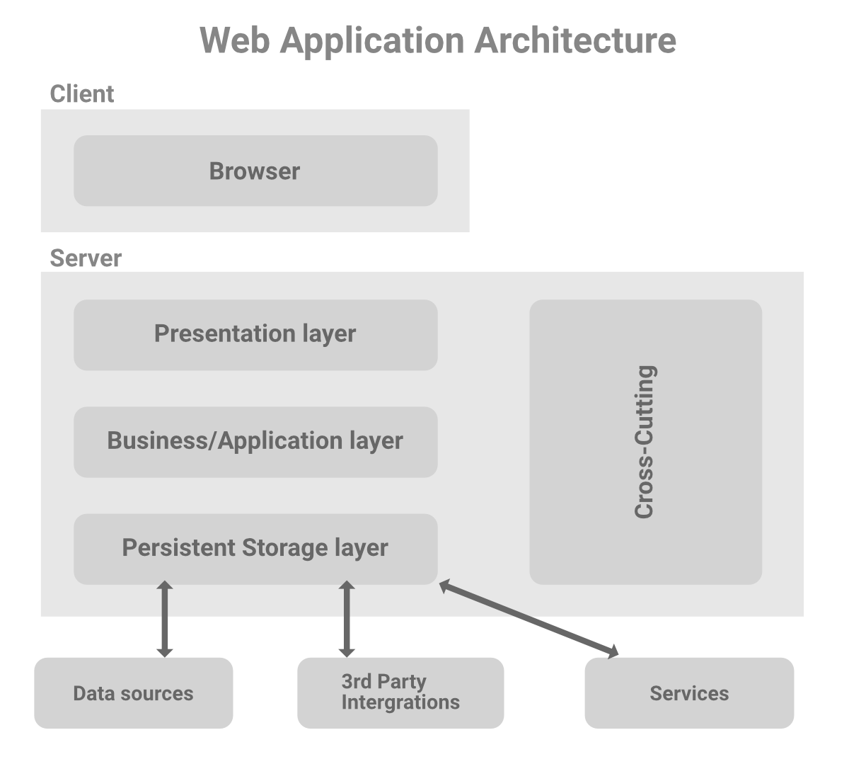

1. **Use Case Diagram**

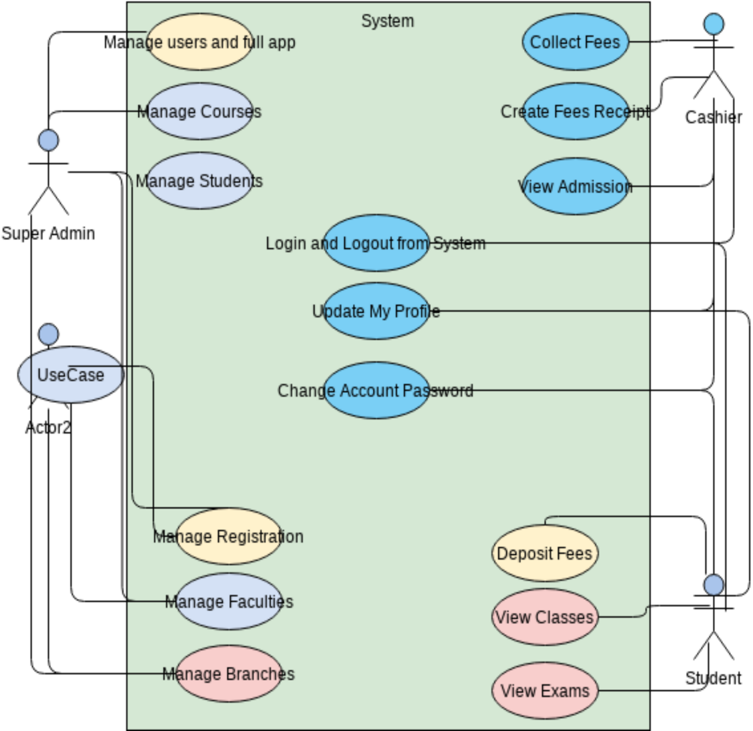

1. **User Characteristics**

**6.1 Prospective Students:** These users are potential applicants who are exploring the college's offerings, academic programs, campus facilities, admission requirements, and application processes. They may be looking for information about majors, minors, extracurricular activities, scholarships, and campus tours.

**6.2 Current Students:** These users are enrolled students who visit the website for various purposes. They may seek information about academic calendars, course registration, campus resources (libraries, labs, career services), campus events, student organizations, housing options, and student support services.

**6.3 Faculty and Staff:** These users are part of the college's academic and administrative staff. They may need access to faculty directories, departmental information, teaching resources, employee benefits, and internal communication tools.

**6.4 Alumni:** These users are former students who have graduated from the college. They may visit the website to stay connected with the college community, access alumni directories, participate in alumni events, donate to the college, or explore career services for alumni.

**6.5 Parents and Guardians:** These users are the parents or guardians of current or prospective students. They may seek information about tuition fees, financial aid, academic programs, campus safety, and support services available to students.

**6.6 Visitors and Community Members:** These users are individuals who are not directly affiliated with the college but may have an interest in its activities. They may be looking for information about public events, guest lectures, continuing education programs, or community engagement initiatives.

**6.7 International Students:** These users are prospective or current students from foreign countries who require specific information about international admissions, visa requirements, English language proficiency exams, cultural integration, and support services for international students.

1. **Sample Code**

<!DOCTYPE html>

<html>

<head>

<title>Home Page</title>

<meta charset="utf-8">

<meta name="viewport" content="width=device-width, initial-scale=1">

<link rel="stylesheet" href="https://maxcdn.bootstrapcdn.com/bootstrap/3.4.1/css/bootstrap.min.css">

<script src="https://ajax.googleapis.com/ajax/libs/jquery/3.6.3/jquery.min.js"></script>

<script src="https://maxcdn.bootstrapcdn.com/bootstrap/3.4.1/js/bootstrap.min.js"></script>

<meta name="viewport" content="width=device-width, initial-scale=1">

<style>

* {box-sizing: border-box;}

body {font-family: Verdana, sans-serif;}

.mySlides {display: none;}

img {vertical-align: middle;}

/* Slideshow container */

.slideshow-container {

max-width: 100%;

position: relative;

margin: auto;

}

/* Caption text */

.text {

color: #f2f2f2;

font-size: 15px;

padding: 8px 12px;

position: absolute;

bottom: 8px;

width: 100%;

text-align: center;

}

/* Number text (1/3 etc) */

.numbertext {

color: #f2f2f2;

font-size: 12px;

padding: 8px 12px;

position: absolute;

top: 0;

}

/* The dots/bullets/indicators */

.dot {

height: 15px;

width: 15px;

margin: 0 2px;

background-color: #bbb;

border-radius: 50%;

display: inline-block;

transition: background-color 0.6s ease;

}

.active {

background-color: #717171;

}

/* Fading animation */

.fade {

animation-name: fade;

animation-duration: 5s;

}

@keyframes fade {

from {opacity: .4}

to {opacity: 1}

}

/* On smaller screens, decrease text size */

.navbar {

overflow:visible;

background-color: #333;

}

.navbar a {

float: left;

font-size: 16px;

color: white;

text-align: center;

padding: 14px 16px;

text-decoration: none;

}

.dropdown {

float: left;

overflow:visible;

}

.dropdown .dropbtn {

font-size: 16px;

border: none;

outline: none;

color: white;

padding: 14px 16px;

background-color: inherit;

font-family: inherit;

margin: 0;

}

.navbar a:hover, .dropdown:hover .dropbtn {

background-color: grey;

}

.dropdown-content {

display: none;

position: absolute;

background-color:rgb(140, 121, 121);

min-width: 160px;

box-shadow: 0px 8px 16px 0px rgba(0,0,0,0.2);

z-index: 1;

}

.dropdown-content a {

float: none;

color: black;

padding: 15px 50px;

text-decoration: none;

display:inline-block;

text-align: left;

}

.dropdown-content a:hover {

background-color: #ddd;

}

.dropdown:hover .dropdown-content {

display: block;

}

</style>

</head>

<body style="background-color: rgb(255, 255, 255);">

<div class="navbar">

<div style="margin-left: 40%;">

<a href="Homepage.html">Home</a>

<div class="dropdown">

<button class="dropbtn">Courses

<i class="fa fa-caret-down"></i>

</button>

<div class="dropdown-content">

<a href="BtechPage.html"> School of Engineering and Technology</a>

<a href="BScPage.html">School Of Paramedics & Allied Health Science</a>

<a href="BBA.html">School of Management</a>

</div>

</div>

<a href="#news">News</a>

</div>

<div class="navbar-header">

<img src="cutm1 logo1.png" style="height: 50px;width:50px; opacity: 10; margin-top: -120px;"></a>

</div>

</div>

</header>

</div>

</main>

<div>

<h1 style="text-align: center; font-family: 'Times New Roman', Times, serif; color: darkblue; font-size: 65px;">CENTURION UNIVERSITY OF <br> TECHNOLOGY AND MANAGEMENT </h1>

<h3 style="text-align: center; font-family: 'Franklin Gothic Medium', 'Arial Narrow', Arial, sans-serif; color:white; font-size: 35px; font-style: italic;"> ANDHRA PRADESH, &nbsp; VIZIANAGARAM </h3>

</div>

<br>

<div class="slideshow-container">

<div class="mySlides fade">

<div class="numbertext">1 / 3</div>

<img src="Homepage.jpg" style="width:100%">

<div class="text">Caption Text</div>

</div>

<div class="mySlides fade">

<div class="numbertext">2 / 3</div>

<img src="1.jpg" style="width:100%;">

<div class="text">Caption Two</div>

</div>

<div class="mySlides fade">

<div class="numbertext">3 / 3</div>

<img src="2.jpg" style="width:100%">

<div class="text">Caption Three</div>

</div>

</div>

<br>

<div style="text-align:center">

<span class="dot"></span>

<span class="dot"></span>

<span class="dot"></span>

</div>

<script>

let slideIndex = 0;

showSlides()

}

slideIndex++;

if (slideIndex > slides.length) {slideIndex = 1}

for (i = 0; i < dots.length; i++) {

dots[i].className = dots[i].className.replace(" active", "");

}

slides[slideIndex-1].style.display = "block";

dots[slideIndex-1].className += " active";

setTimeout(showSlides, 3500); // Change image every 2 seconds

}

</script>

</div>

</body>

</html>

1. **Outputs**

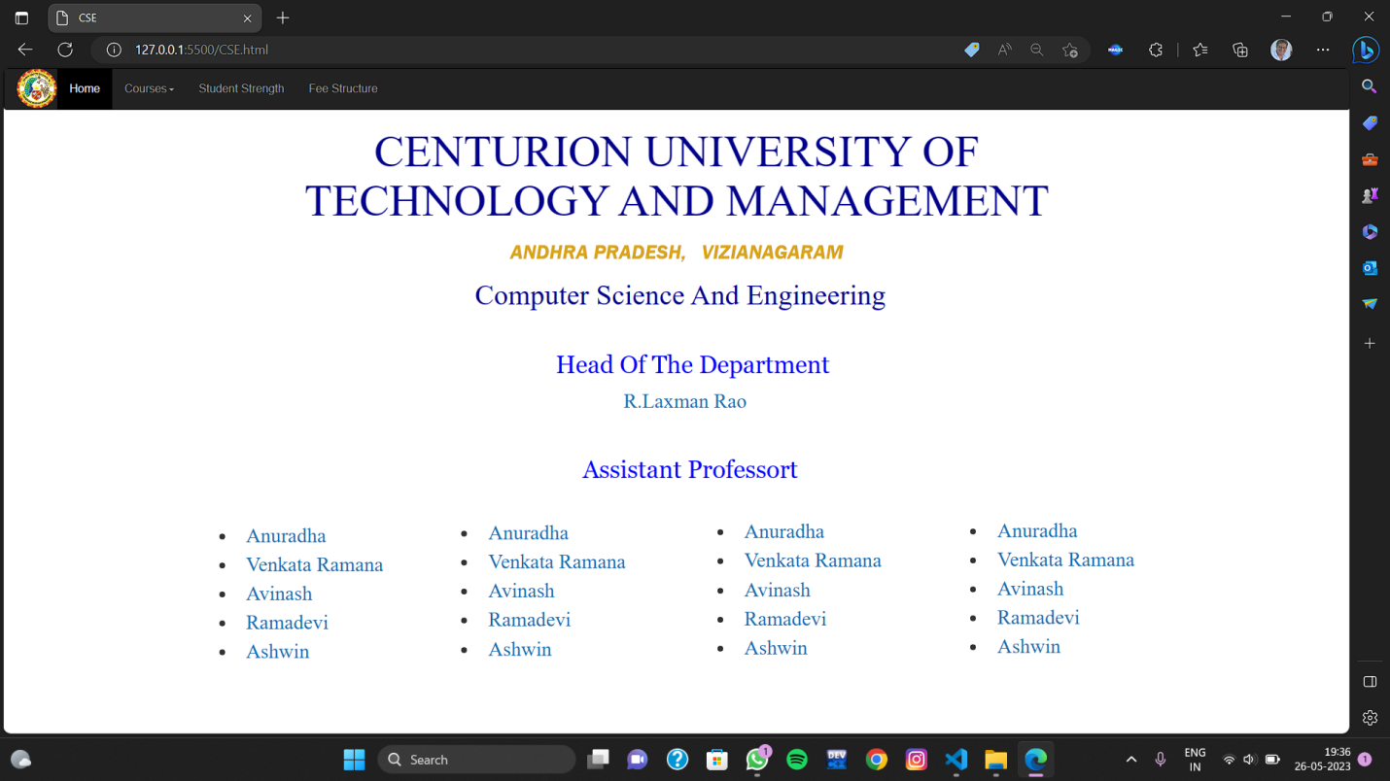

**Fig 8.1**

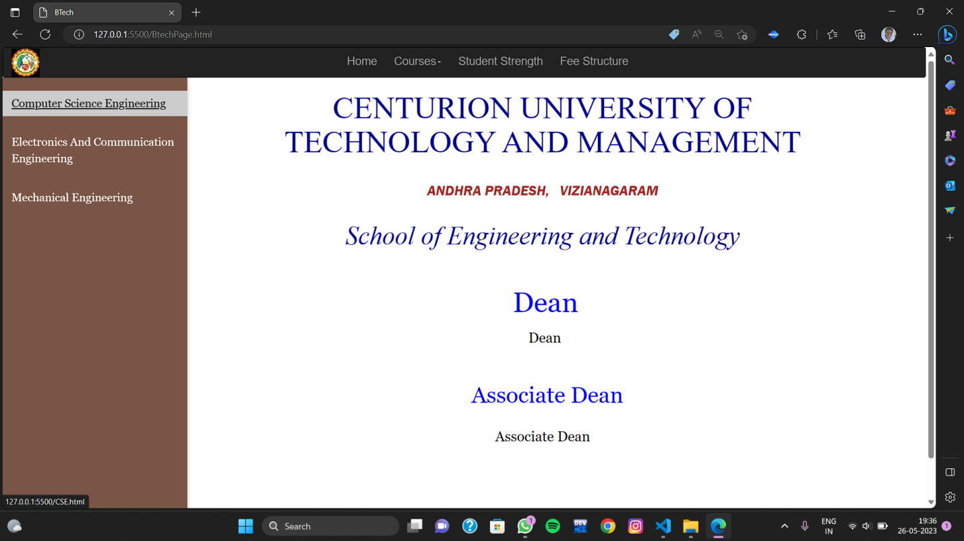

**Fig 8.2**

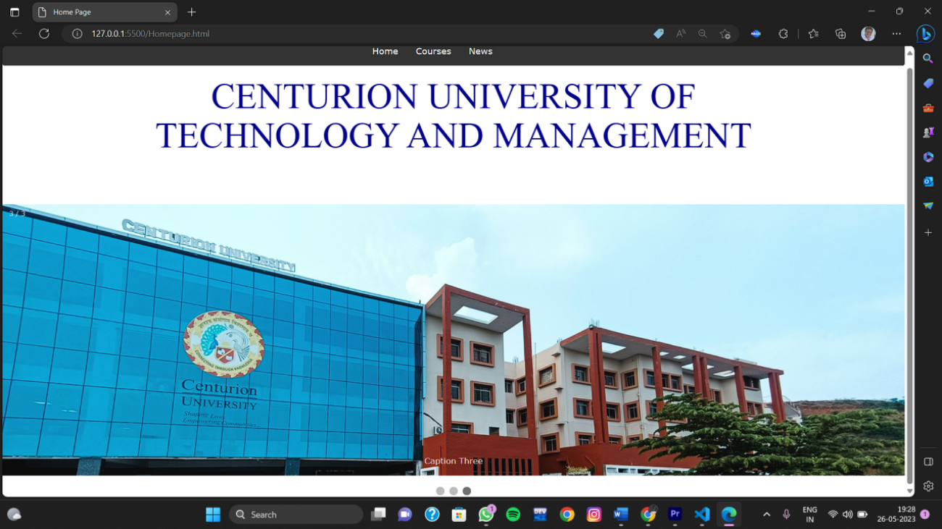

**Fig 8.3**

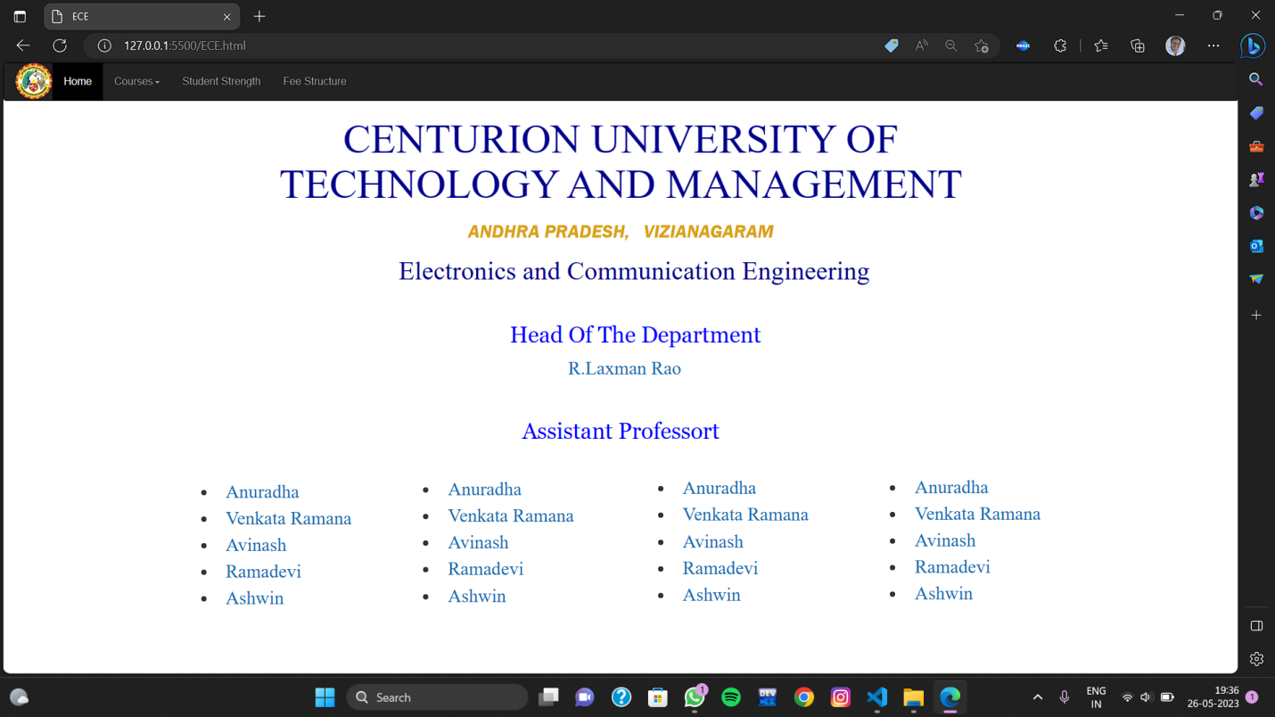

**Fig 8.4**

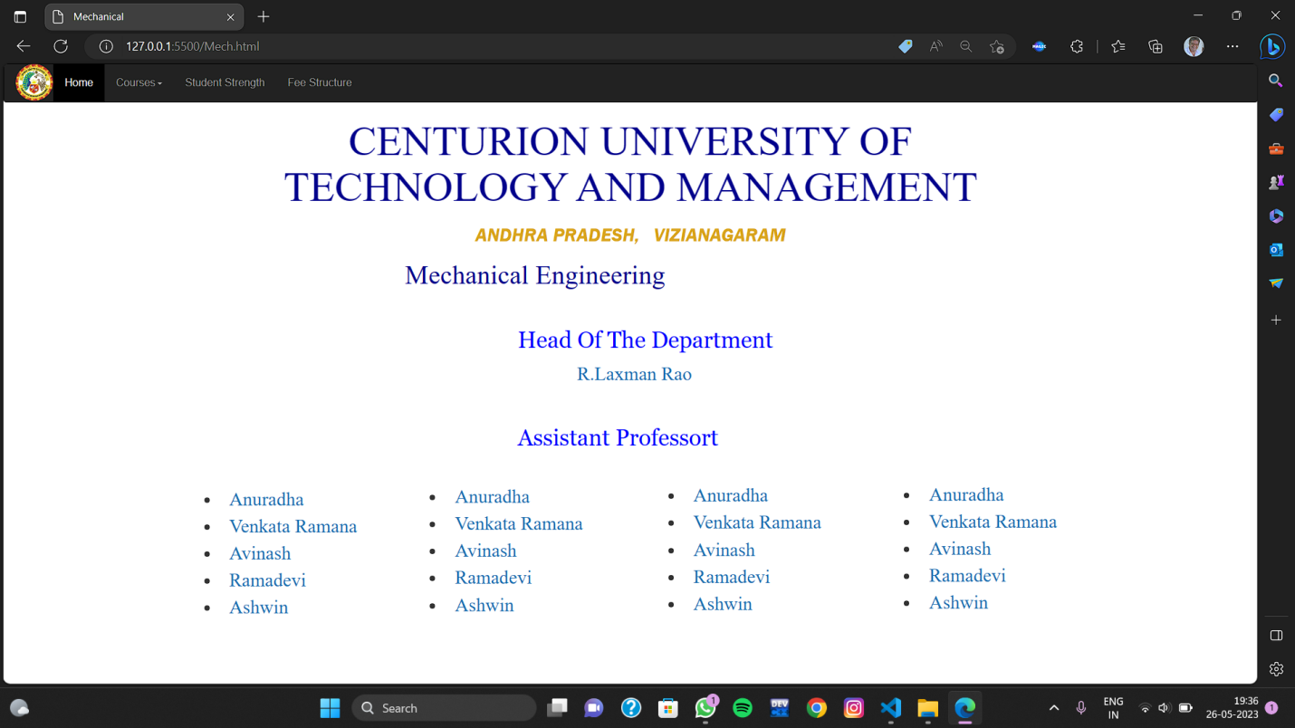

**Fig 8.5**

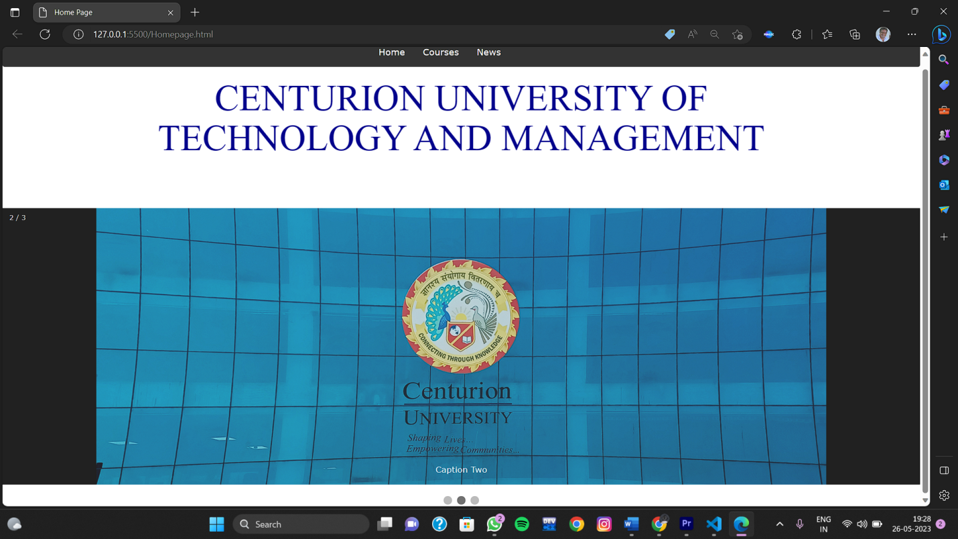

**Fig 8.6**

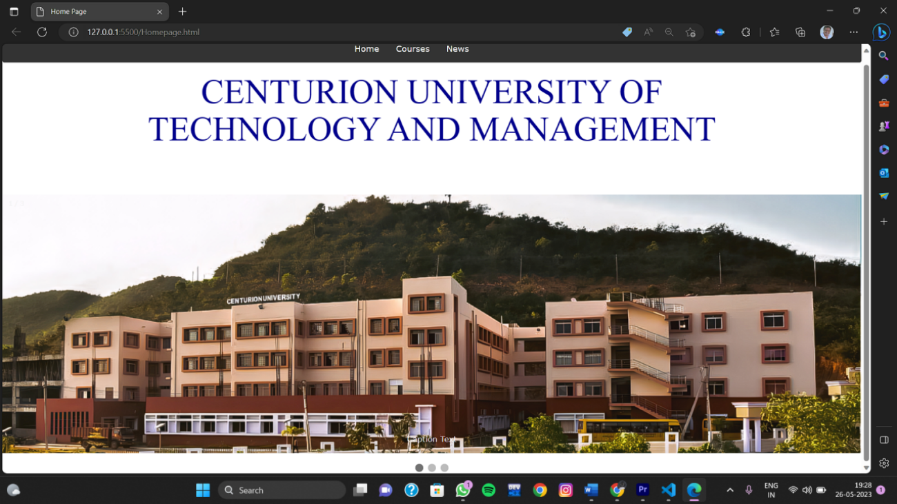

**Fig 8.7**

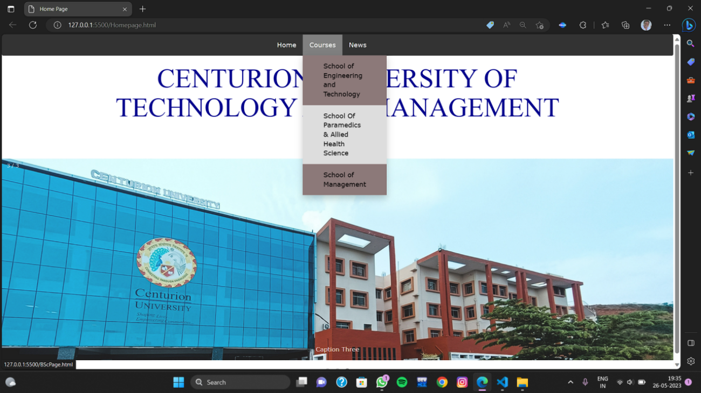

**Fig 8.8**

**Conclusion**

Creating a college website using HTML and CSS offers numerous benefits and allows for a flexible and customizable design.HTML provides the structure and content of the website.creating a college website using HTML and CSS empowers you to build a visually appealing,well-structured,and flexible platform that effectively represents your college’s Brand and provides a seamless user experience for visitors.